Manipulating Data
Create EmpTest from Emp table by copying structure and data.
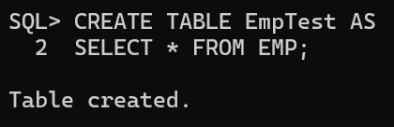
Add a new row into the EmpTest table for Empno, Ename, Sal columns. In Ename should have the Current User.
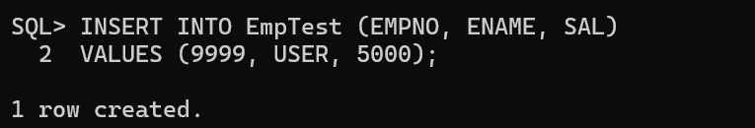
Update EmpTest by increasing the Salary of TURNER by 15%. Confirm your changes.
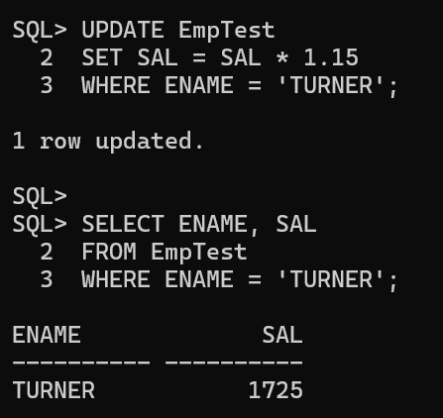
Update the salary of Smith with salary of Scott using EmpTest table.
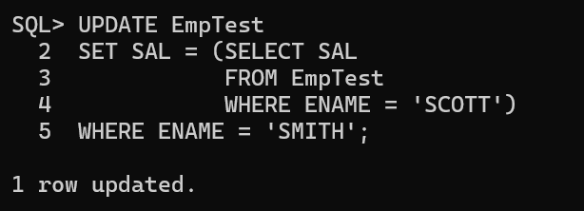
Increase all the employees salary by 10% in EmpTest table who are working in NEW YORK.
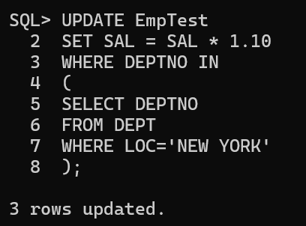
Delete all the Comm data from EmpTest Table.
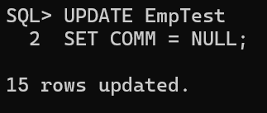
Delete all the employees from EmpTest table who are working in SALES dept.
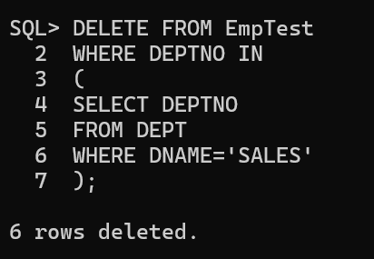
Delete all who are working with that employee, except that Employee. (Prompt for the ENAME).
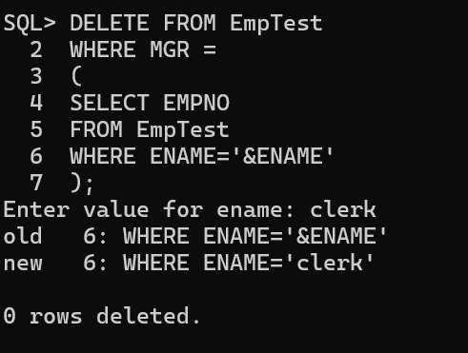
Create Emp2 from Emp by only copying Empno, Ename, Sal without copying data.
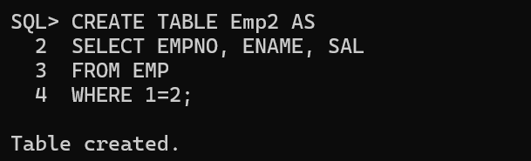
Create Emp3 from Emp by only copying Empno, Job without copying data.
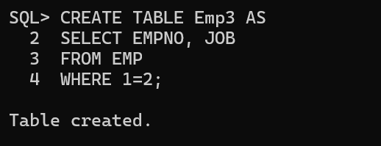
Using multitable insert Emp data into Emp2 and Emp3 Tables.
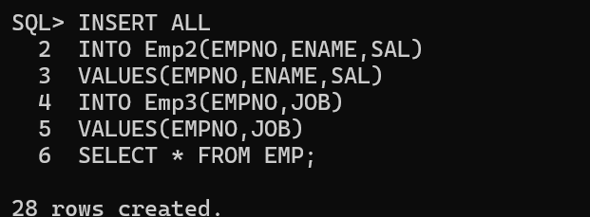
Truncate Emp2 Table and insert following two rows as follows:
- 7788, SMITH, 4500
- 7654, JACK, 3500
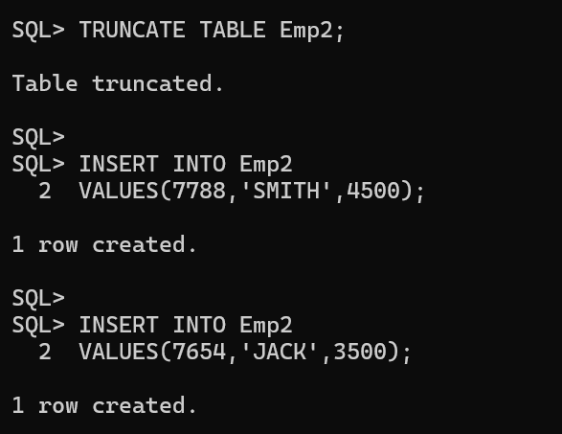
Commit the Data.
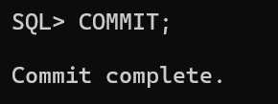
Using Merge statement insert and update Emp2 using Emp.
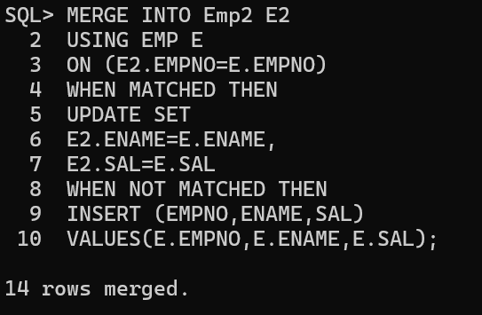
Verify your changes.
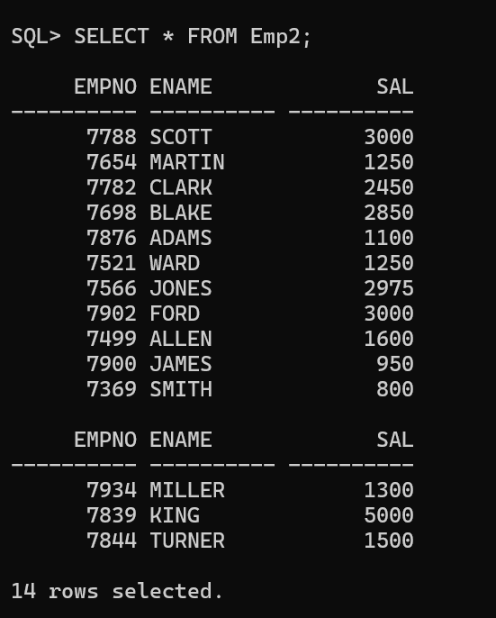
Rollback the Data.
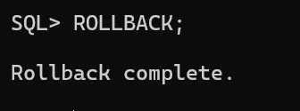
Using Merge statements update Emp2 table for only Empno=7788 and Insert only those employees whose salary is more than 3000.
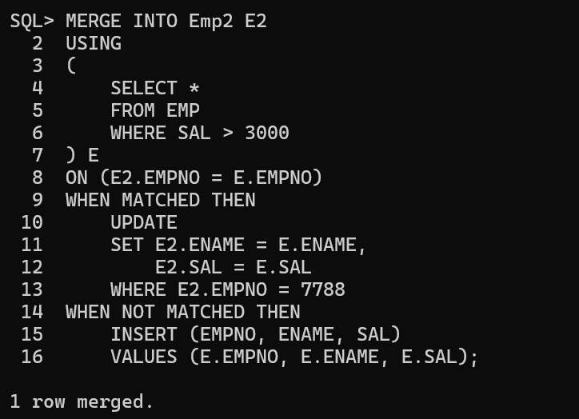
Verify your changes.
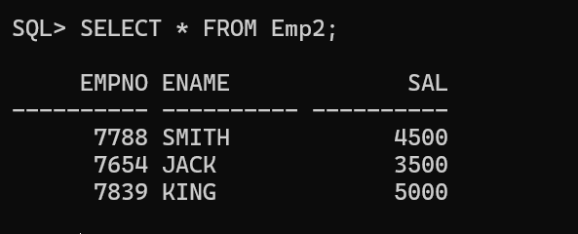
Create a User WIPRO.
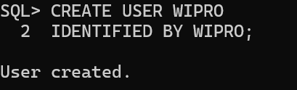
Grant ALL permission on EMP table from SCOTT to WIPRO user.
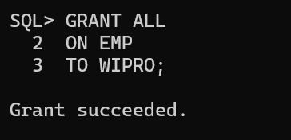
Delete all the employees in deptno 10 and do not issue a Commit.
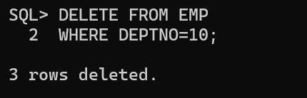
From WIPRO user delete all the employees from SCOTT.EMP table in DEPTNO=10. What happens and Why?
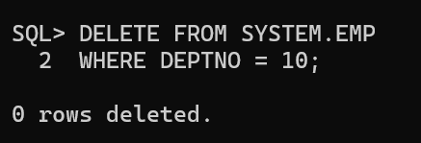
Issue a Rollback in SCOTT user and Check the WIPRO user.
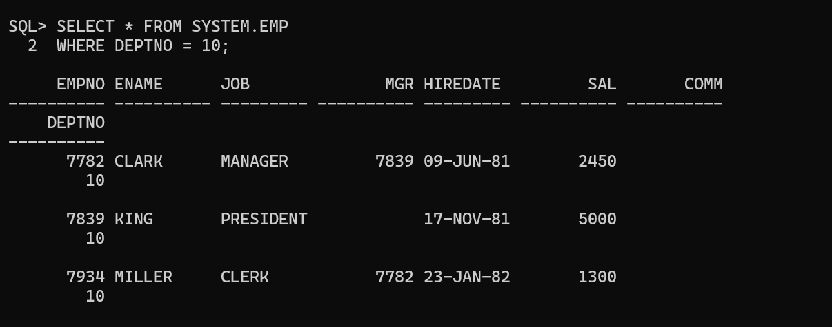
In SCOTT user give a query on EMP using FOR UPDATE clause with WAIT 20 seconds? What happens?
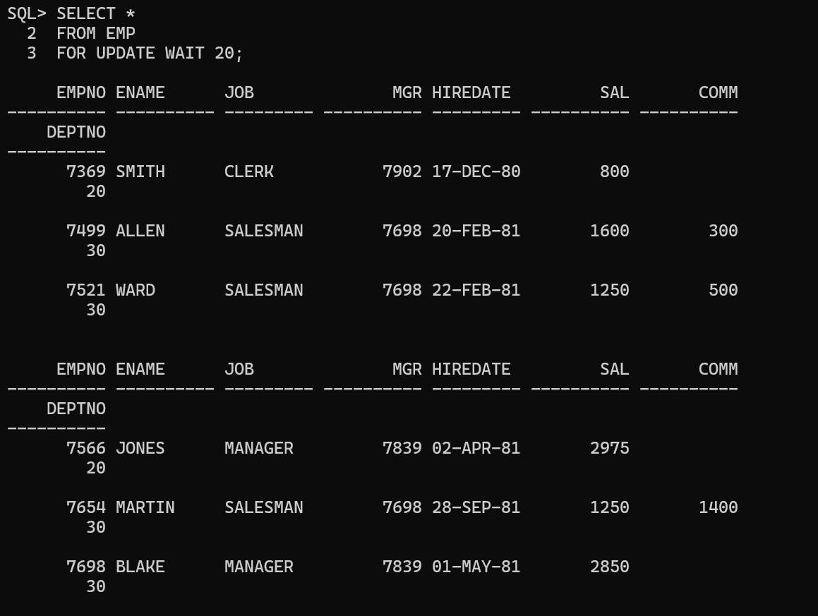
In WIPRO User issue a ROLLBACK and now check in SCOTT user.
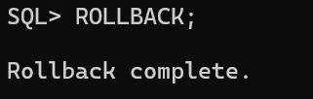
ROLLBACK all the transactions in SCOTT and WIPRO Users.
